**HL Unit 5** **– Abstract Data Structures**  
Quiz 2 – 2D Arrays

|  |  |  |  |
| --- | --- | --- | --- |
| **Question 1** | | | |
| Objectives: | 5.1.4, 5.1.5 | Exam Reference: | Nov-14 12 |

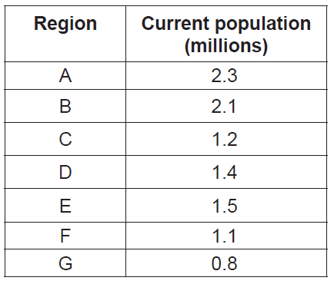A population study divides a metropolitan area into seven regions: A–G.  
The following table shows the current population (in millions) of the regions.

Two one-dimensional arrays, Region and Curr_Pop, are used to hold this data.

For example, Region[0] ='A'. The population in region A is 2.3 million and 2.3 is found in

Curr_Pop[0].

1. Construct the algorithm that will output the total population in the metropolitan area. [3]

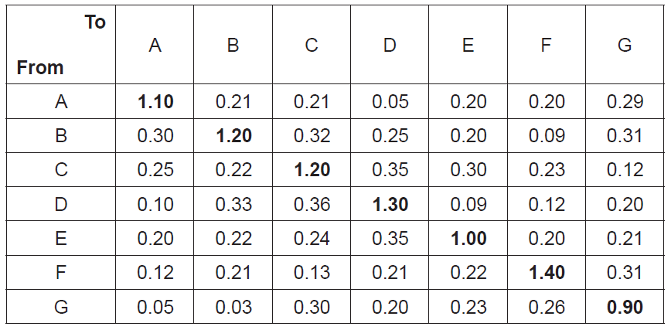 The numbers in the following table represent expected percentages of yearly migration from  
 one region to another, obtained by analysing historical migration data. For example, it is  
 expected that 0.32 % of the current population of region B will move to region C.  
 The diagonal entries represent a region’s internal growth rate. For example, the population  
 of region C is expected to increase by 1.2 % as a result of the births and deaths of people  
 currently living in region C.

1. (i) State the percentage of the population of region G that are expected to move to

region A. [1]

(ii) Determine the number of people from region B who are expected to move to  
 region E. [1]

(iii) Describe how the change in population of region F in one year could be

determined. [3]

1. Construct the algorithm that will predict the population in each region after 10 years.

You should assume that the yearly migration percentages, given in the table on page 8,

remain the same over the 10 years. [7]

|  |  |  |  |
| --- | --- | --- | --- |
| **Question 2** | | | |
| Objectives: | 5.1.4, 5.1.5 | Exam Reference: | Nov-16 12 |

A two-dimensional array, A, has N rows and N columns, where N is a positive integer.

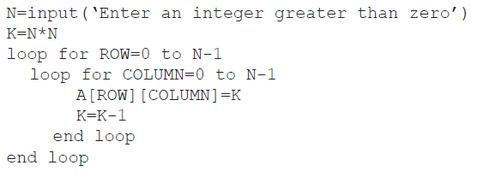The following algorithm is written to fill array A with the numbers 1, 2, 3,…, N2.

1. Trace the algorithm, with an input of N=3, to show the contents of array A after the

algorithm has been executed. [3]

There are many different ways of placing the numbers 1 to N2 into an N × N   
 two-dimensional array.  
  
 The following two-dimensional array, with dimensions 5 × 5 has been filled in a circular  
 (spiral) pattern with numbers 1 to 52.

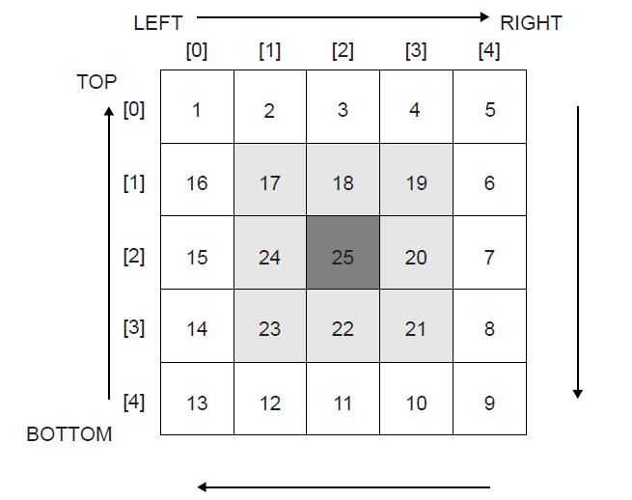

The general process of filling an N × N two-dimensional array, in a circular (spiral) pattern,  
with numbers from 1 to N2 could be described as follows:

• initialize Z=1,

• initialize TOP, BOTTOM, LEFT and RIGHT,

• iterate until the whole array is filled,

• each time Z is placed correctly increase the value of Z by 1,

• fill the elements of the TOP row starting from LEFT to RIGHT,

• increase TOP by 1 before filling the elements of the RIGHT column,

• fill the elements of the RIGHT column starting from TOP to BOTTOM,

• decrease RIGHT by 1 before filling the elements of the BOTTOM row,

• and continue filling the BOTTOM row and LEFT column in a similar way,  
 adjusting TOP, RIGHT, BOTTOM and LEFT accordingly.

1. (i) State the initial values for TOP, BOTTOM, LEFT and RIGHT. [1]

(ii) State the consequence of not increasing TOP by 1 before starting to fill the  
 elements of the RIGHT column. [1]

(iii) In the algorithm described above, state the indices (subscripts) of the first and  
 the last element to be filled in the BOTTOM row. [1]

1. Construct, in pseudocode, an algorithm to fill an N × N two-dimensional array, in a

circular (spiral) pattern, with numbers from 1 to N2 as described above. [9]